**Using SQL Create a source table for data warehouse.**

CREATE TABLE autoxyz(

id serial PRIMARY KEY

item_name varchar(255),

brand varchar(255),

sold_by varchar(255),

category varchar(255),

day int,

month varchar(255),

quarter varchar(255),

year int,

location_name varchar(255),

state varchar(255),

pin_code int,

driver_name varchar(255)

duty_time varchar(255)

qty_sold int,

amt_sold int

);

INSERT INTO autoxyz(item_name,

brand,

sold_by,

category,

day,

month,

quarter,

year,

location_name,

state,

pin_code,

driver_name,

duty_time,

qty_sold,

amt_sold)

VALUES('Car','Model X','Tesla','Four wheeler',13,'June','Q2',2024,'New Baneshwor','Bagmati','123','Jack','Evening',2,13000),

('Car','Model Y','Tesla','Four wheeler',21,'November','Q4',2024,'Koteshwor','Bagmati','123','Candace','Morning',1,8000);

SELECT * FROM autoxyz;

**Using SQL Create time dimension table for data warehouse.**

CREATE TABLE timedim (

t_id serial PRIMARY KEY,

day int,

month varchar(255),

quarter varchar(255),

year int

);

INSERT INTO timedim(

day,

month,

quarter,

year

)

SELECT day,month,quarter,year FROM autoxyz;

SELECT * FROM timedim;

**Using SQL Create location dimension table for data warehouse.**

CREATE TABLE locationdim (

l_id serial PRIMARY KEY,

location_name varchar(255),

state varchar(255),

pin_code int

);

INSERT INTO locationdim(

location_name,

state,

pin_code

)

SELECT location_name,state,pin_code FROM autoxyz;

SELECT * FROM locationdim;

**Using SQL Create item dimension table for data warehouse.**

CREATE TABLE itemdim (

i_id serial PRIMARY KEY,

item_name varchar(255),

brand varchar(255),

sold_by varchar(255),

category varchar(255)

);

INSERT INTO itemdim(

item_name,

brand,

sold_by,

category

)

SELECT item_name,brand,sold_by,category FROM autoxyz;

SELECT * FROM itemdim;

**Using SQL Create vehicle dimension table for data warehouse.**

CREATE TABLE vehicledim(

vehicle_id serial PRIMARY KEY,

driver_name varchar(255),

duty_time varchar(255)

);

INSERT INTO vehicledim(

driver_name,

duty_time

)

SELECT driver_name,duty_time FROM autoxyz;

SELECT * FROM vehicledim;

**Using SQL Create sales fact table for data warehouse.**

CREATE TABLE salesfact(

item_id int REFERENCES itemdim(i_id),

time_id int REFERENCES timedim(t_id),

location_id int REFERENCES locationdim(l_id),

qty_sold int

);

INSERT INTO salesFact(

item_id,

time_id,

location_id,

qty_sold

)

SELECT i_id,t_id,l_id,qty_sold FROM autoxyz c

LEFT OUTER JOIN timedim t ON t.day = c.day AND t.month = c.month AND t.quarter = c.quarter AND t.year = c.year

LEFT OUTER JOIN itemdim i ON i.item_name = c.item_name AND i.brand = c.brand AND i.sold_by = c.sold_by AND i.category = c.category

LEFT OUTER JOIN locationdim l ON l.location_name = c.location_name AND l.state = c.state AND l.pin_code = c.pin_code;

SELECT * FROM salesfact;

**Using SQL Create delivery fact table for data warehouse.**

CREATE TABLE deliveryfact(

item_id int REFERENCES itemdim(i_id),

location_id int REFERENCES locationdim(l_id),

vehicle_id int REFERENCES vehicledim(vehicle_id)

);

INSERT INTO deliveryfact(

item_id,

location_id,

vehicle_id

)

SELECT i_id, l_id, vehicle_id FROM autoxyz c

LEFT OUTER JOIN itemdim i ON i.item_name = c.item_name AND i.brand = c.brand AND i.sold_by = c.sold_by AND i.category = c.category

LEFT OUTER JOIN locationdim l ON l.location_name = c.location_name AND l.state = c.state AND l.pin_code = c.pin_code

LEFT OUTER JOIN vehicledim v ON v.driver_name = c. driver_name AND v.duty_time = c. duty_time;

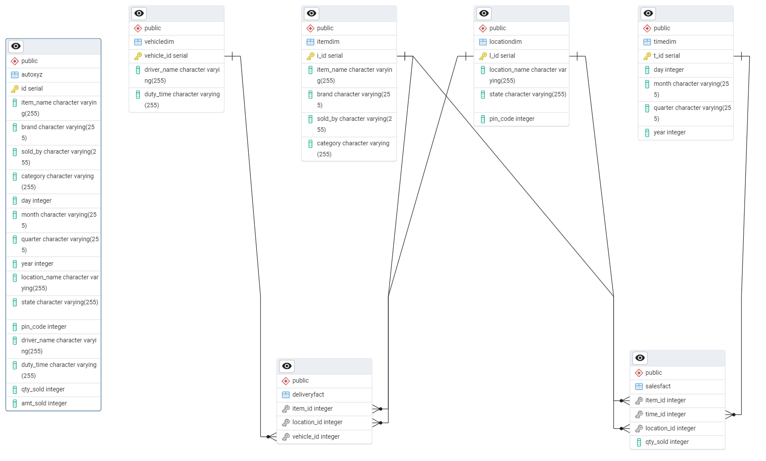SELECT * FROM deliveryfact;

**Query to select item_id, location_id, vehicle_id, driver_name, duty_time records where duty time = morning**

SELECT d.item_id, d.location_id, v.vehicle_id, driver_name, duty_time FROM deliveryfact d LEFT OUTER JOIN vehicledim v ON d.vehicle_id = v.vehicle_id WHERE duty_time='Morning';